Docker Compose
1. Docker Compose
Docker Compose is used to define and run multiple containers on a single machine.
For example, your application might need:
- Frontend container
- Backend container
- Database container
Instead of running each container manually, you define everything in a compose.yml file.
Architecture
Docker Compose
│
▼
┌─────────────────────┐
│ Single Server │
│ │
│ ┌───────┐ │
│ │ Web │ │
│ └───────┘ │
│ │
│ ┌───────┐ │
│ │ API │ │
│ └───────┘ │
│ │
│ ┌───────┐ │
│ │ MySQL │ │
│ └───────┘ │
└─────────────────────┘

Docker Compose is a lightweight orchestration tool for defining and running multi-container Docker applications. In a typical setup, services like a web server, backend API, database, and cache run in separate containers. It allows you to configure and manage them together as a single application using one docker-compose.yml file.
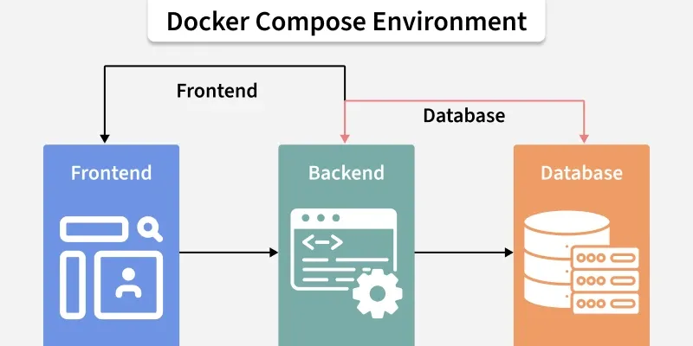
Overcoming the Complexity of Multi-Container Setups
Docker is excellent at creating and running individual containers, managing the lifecycle and communication between them manually presents significant challenges:
- Complex Configuration: Running each container requires long and complex docker run commands with flags for networking, ports, volumes, and environment variables. This becomes difficult to manage and reproduce consistently.
- Manual Networking: To make containers talk to each other, you would have to manually create Docker networks, find the internal IP address of each container, and hardcode these fragile, temporary IPs into your application's code.
- Lack of Reproducibility: A manual setup is prone to human error and makes it incredibly difficult to ensure that the application runs the same way on a developer's machine, a testing server, and in production. This is the classic "it works on my machine" problem.
Docker Compose directly addresses these issues by providing a declarative, automated, and reproducible way to manage your entire application stack. You declare the desired state of your application in the YAML file, and Docker Compose handles the rest.
Example docker-compose.yml
Here’s a sample Compose file that defines two services, a shared network, and a volume:
version: '3.8'

services:
web:
image: nginx:latest
ports:
- "80:80"
networks:
- frontend
volumes:
- shared-volume:/usr/share/nginx/html
depends_on:
- app

app:
image: node:14
working_dir: /app
command: node server.js # Specify a command
networks:
- frontend
volumes:
- shared-volume:/app/data

networks:
frontend:
driver: bridge

volumes:
shared-volume: # Remove incorrect syntax
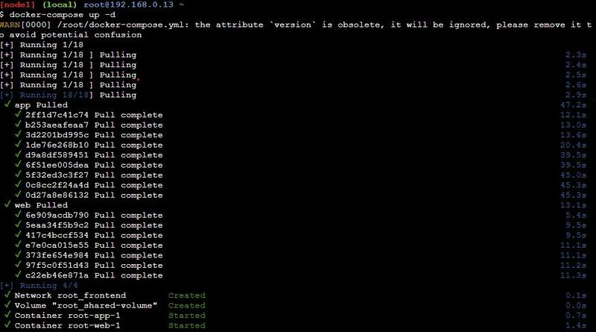
Explanation:
- The web service runs an Nginx container, and app runs a Node.js container.
- Both services connect through the frontend network, allowing them to communicate.
- The shared-volume volume is mounted in both containers, providing shared storage for files.
Docker Compose Services
- In Docker Compose, every component of your application operates as a separate service, with each service running a single container tailored to a specific role—such as a database, web server, or cache.
- These services are defined within the `services` section of the `docker-compose.yml` file. This section lets you configure each service individually, specifying details like the Docker image to pull, environment variables, network connections, and storage options.
- Through this setup, you can control how each part of your application interacts, ensuring smooth communication and resource management across the services.
Key Service Configuration Options
- Image: Image option defines which Docker image we are going to use by the service from the Docker Hub or any other registry.
- Build: Instead of pulling an image, you can build one locally by specifying a directory containing a Dockerfile. The build is ideal for including custom code in your application.
- Ports: This setting maps a container's internal ports to those on the host machine, enabling access to services from outside the container.
- Volumes: Volumes attach persistent storage to a service ensuring that the data remains accessible even when a container restart.
- Environment: Environment variables allow you to pass configurations or sensitive information, like database credentials or API keys, to the service.
- Depends_on: Depends_on controls the startup order of services, ensuring that certain containers are running before others begin.
Example of docker-compose.yml Configuration
Here’s a sample configuration that demonstrates how these options are used:
version: '3.8'
services:
db:
image: postgres:13
environment:
- POSTGRES_USER=user
- POSTGRES_PASSWORD=pass
volumes:
- db_data:/var/lib/postgresql/data

web:
build: ./web
ports:
- "5000:5000"
volumes:
- web_data:/usr/src/app
environment:
- DATABASE_URL=postgres://user:pass@db:5432/mydb
depends_on:
- db

volumes:
db_data:
web_data:
Explanation:
- The db service runs a PostgreSQL container. It uses environment variables to set up a database username and password, and stores data on the db_data volume to ensure it’s retained.
- The web service is built from a Dockerfile in the ./web directory and exposes port 5000. The web_data volume is mounted to store application files persistently. It depends on the db service, ensuring the database is available when the web service starts.
Docker Compose Networks
Docker Compose deployments use networks to allow secure communications between the services. Services defined in a docker-compose.yml file are by default placed on one network and are able to connect to each other without any additional setup. For more strict control, you can create additional networks and assign services to them in order to control the way they communicate or to separate some groups of services as the need arises.
Key Network Configuration Options
- Driver: Driver are used in the network driver type, such as bridge (the default for local networks) or overlay (for multi-host networks in Docker Swarm), which determines how services connect to each other.
- Driver Options (driver_opts): Driver Options(driver_opts) allows for additional settings on the network driver, useful for fine-tuning network behavior to meet specific needs.
- IP Address Management (ipam):IP address management configures network-level IP settings, like subnets and IP ranges, to give you greater control over the IP address space assigned to your services.
Example docker-compose.yml with Custom Networks
Below is an example Compose file that sets up two networks, one for database communication and another for web access.
version: '3.8'

services:
db:
image: postgres:13
networks:
- backend

web:
image: nginx:latest
networks:
- frontend
- backend
ports:
- "80:80"

networks:
frontend:
driver: bridge

backend:
driver: bridge
ipam:
config:
- subnet: 172.16.238.0/24
Explanation:
- The db service uses thebackend network, isolating it from the frontend network to limit access.
- The web service is connected to both frontend and backend networks, allowing it to communicate with the db service while remaining accessible via the frontend network.
- The backend network includes IPAM settings with a specific subnet range, ensuring custom IP address management.
Docker Compose Volumes
Volumes in docker compose are used to persist data created or used by the docker containers. By doing so they enable the data to persist even if containers are stopped or removed in your docker-compose. Within a docker-compose. yml file, the volumes section describes all the volumes that are attached to the services allowing you to manage data that exists independently of the container lifecycle.
Key Volume Configuration Options
- External: Set true to signify that the volume was created externally, outside of Docker Compose (such as via docker volume create) and simply referenced in the configuration.
- Driver: This indicates which volume driver the volume should use, and it controls how are these volumes being handled. By default, the driver is local, but other options are also available.
- Driver Options (driver_opts): Additional options to customize the volume driver like filesystem type or different storage parameters.
Example docker-compose.yml with Volumes
Here’s a practical example showing how to configure a volume for a Pos-tgreSQL database, ensuring that its data is stored persistently.
version: '3.8'

services:
db:
image: postgres:13
environment:
- POSTGRES_USER=user
- POSTGRES_PASSWORD=pass
volumes:
- db_data:/var/lib/postgresql/data

volumes:
db_data:
driver: local
driver_opts:
type: none
o: bind
device: /path/to/local/db_data
Explanation
- The db service runs a PostgreSQL container, with its data stored in the db_data volume. This setup ensures that the database information remains intact across restarts or removals of the container.
- The db_data volume is configured to use the localdriver, and it has driver options set to create a bind mount pointing to a specific path on the host system (/path/to/local/db_data). This means that all database files are saved in that designated directory on the host.
- By using volumes in this way, you can keep essential data safe and easily accessible, separate from the container itself.
Set Environment Variables in Docker Compose
Environment variables are a simple and effective way to pass configuration settings from your host operating system through Docker Compose in order to get to your services. You can set these variables directly on the service definition by using the environment section or load them from an external file.
- Inline: you may declare env vars directly in the service definition.This approach is simple and gives everything in one place.
- env_file: This option allows you to load environment variables from an external file, making it easier to manage configuration, especially when dealing with many variables.
Example docker-compose.yml Using Environment Variables
Here’s an example that demonstrates both methods of setting environment variables for a web application and a database service.
version: '3.8'

services:
db:
image: postgres:13
environment:
- POSTGRES_USER=user
- POSTGRES_PASSWORD=pass
volumes: - db_data:/var/lib/postgresql/data

web: image: my-web-app:latest
build: ./web
environment:
- DATABASE_URL=postgres://user:pass@db:5432/mydb
env_file:
- .env

volumes:
db_data:
Explanation
- In the db service, the POSTGRES_USER and POSTGRES_PASSWORD environment variables are defined inline, specifying the database credentials directly.
- The web service uses an inline variable for DATABASE_URL, which connects to the PostgreSQL database. Additionally, it loads environment variables from an external file named .env. This file can contain various settings, such as API keys, application configurations, and other sensitive information.
With a good understanding of these basic principles, developers are ready to use Docker Compose to manage and orchestrate applications that can be quite complex and involve many Docker containers.
Install Docker Compose
We can run Docker Compose on macOs, Widows, and 64-bit Linux.
- For any significant activity, Docker Compose depends on Docker Engine. Depending on your arrangement, we must ensure that Docker Engine is installed either locally or remotely.
- A desktop system such as Docker for Mac and Windows comes with Docker Compose preinstalled.
- Install Docker first as instructed in Docker installation on the Linux system before beginning the installation of Docker Compose.
Install Docker Compose on Ubuntu - A Step-By-Step Guide
Step 1: Update the package Manager
- The following scripts will install the most recent version of Docker Compose and update the package management.
sudo apt-get update
Step 2: Download the Software
- Step 1: Set up the official Docker repository.
- Step 2: Run sudo apt-get install docker-compose-plugin.
- Step 3: Verify with docker compose version.
Step 3: Apply Permissions
- Apply the Executable permissions to the software with the following commands:
sudo chmod +x /usr/local/bin/docker-compose
Step 4: Verify the Download Software
- Verify the whether the docker compose is successfully installed or not with the following command:
docker compose --version
How to Use Docker Compose?
In this project, we will create a straightforward Restfull API that will return a list of fruits. We will use a flask for this purpose. And a PHP application will request this service and show it in the browser. Both services will run in their own containers.
Step 1: Create Project Directory
- First, Create a separate directory for our complete project. Use the following command.
mkdir dockerComposeProject
- Move inside the directory.
cd dockerComposeProject
Step 2: Create API
we will create a custom image that will use Python to serve our Restful API defined below. Then the service will be further configured using aDockerfile.
- Then create a subdirectory for the service we will name it product. and move into the same.
mkdir product
cd product
- Create requirements.txt
Inside the product folder, create a file named requirements.txt and add the following dependencies:
flask
flask-restful
Step 3: Build Python api.py
- The following is the python file that helps in making an API call:
- Create a Dockerfile to define the container in which the above API will run.
from flask import Flask
from flask_restful import Resource, Api

# create a flask object
app = Flask(__name__)
api = Api(app)

# creating a class for Fruits that will hold
# the accessors
class Fruits(Resource):
def get(self):
# returns a dictionary with fruits
return {
'fruits': ['Mango', 'Pomegranate', 'Orange', 'Litchi']
}

# adds the resources at the root route
api.add_resource(Fruits, '/')

# if this file is being executed then run the service
if __name__ == '__main__':
# run the service
app.run(host='0.0.0.0', port=80, debug=True)
Step 4: Create Dockerfile For Python API
FROM python:3
WORKDIR /usr/src/app
COPY requirements.txt .
RUN pip install --no-cache-dir -r requirements.txt
COPY . .
CMD ["python", "api.py"]
FROM accepts an image name and a version that the docker will download from the docker hub. The current working directory's contents can be copied to the location where the server expects the code to be by using the copy command. Moreover, the CMD command takes a list of commands to start the service once the container has been started.
Step 5: Create PHP HTML Website
Let's create a simple website using PHP that will use our API.
- Move to the parent directory and create another subdirectory for the website.
cd ..
mkdir website
cd website
index.php
<!DOCTYPE html>
<html lang="en">
<head>
<title>Fruit Service</title>
</head>
<body>
<h1>Welcome to India's Fruit Shop</h1>
<ul>
<?php
$json = file_get_contents('http://fruit-service');
$obj = json_decode($json);
$fruits = $obj->fruits;
foreach ($fruits as $fruit){
echo "<li>$fruit</li>";
}
?>
</ul>
</body>
</html>
- Now create a compose file where we will define and configure the two services, API and the website.
- Move out of the website subdirectory using the following code.
cd ..
- And then create the file name as . docker-compose.yaml
Step 6: Create Docker-compose.yaml file
- The following is the sample docker compose file code:
version: "3"

services:
fruit-service:
build: ./product
volumes:
- ./product:/usr/src/app
ports:
- 5001:80

website:
image: php:apache
volumes:
- ./website:/var/www/html
ports:
- 5000:80
depends_on:
- fruit-service
Note on depends_on: This option controls the startup order, but it does not wait for the application inside to be ready. If your PHP app tries to connect before the Python app has finished booting, it might fail. In production, use "healthchecks" to solve this.
Docker-compose.yaml File
The first line is optional where we specify the version of the docker-compose tool. Next services define a list of services that our application is going to use. The first service is fruit service which is our API and the second one is our website. The fruit service has a property build that contains the dockerfile that is to be built and created as an image. Volumes define storage mapping between the host and the container so that we can make live changes. Finally, port property exposes the containers port 80 through the host's 5001.
The website service does not use a custom image but we download the PHP image from the Docker hub and then map the websites folder that contains our index.php to /var/www/html (PHP expects the code to be at this location). Ports expose the container port. Finally, the depends_on specifies all the services on which the current service depends.
- The folder structure after creating all the required files and directory will be as follows:
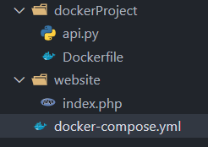
Run the application stack with Docker Compose
- Now that we have our docker-compose.yml file, we can run it.
- To start the application, enter the following command.
docker compose up -d
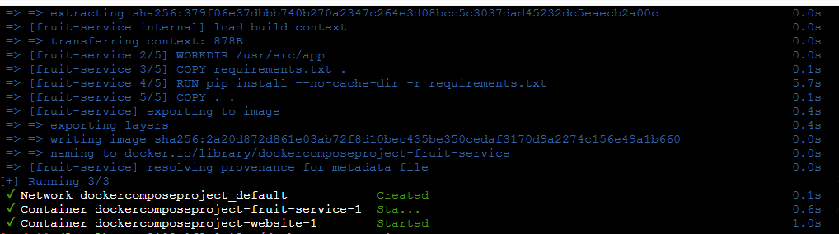
Now all the services will start and our website will be ready to be used at localhost:5000.
- Open your browser and enter localhost:5000.
- 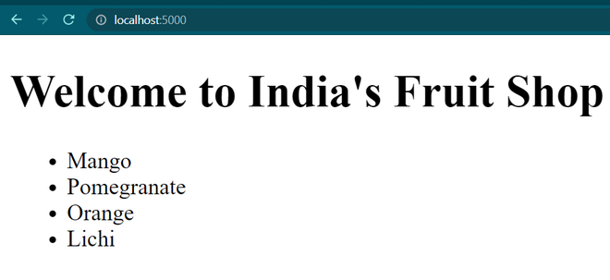
To stop the application, either press CTRL + C or
docker compose stop
Important Docker Compose Commands
docker compose up
- Starts all services defined in docker-compose.yml. Creates containers, networks, and volumes if missing. Add -d to run in background.
Example: docker-compose up -d
docker compose down
- Stops and removes all containers, networks, and volumes created by up. Cleans resources when not needed.
Example: docker-compose down
docker compose ps
- Lists all containers in the Compose app with status details. Useful for monitoring running services.
Example: docker-compose ps
docker compose logs
Shows logs from services. Add service name to filter logs for troubleshooting.
Example: docker compose logs web
docker compose exec
Runs a command inside a running service container. Good for debugging or direct interaction.
Example: docker-compose exec db psql -U user -d mydb
docker compose build
Builds/rebuilds images defined in docker-compose.yml. Use after Dockerfile changes or updates.
Example: docker-compose build
docker compose pull
Pulls the latest images from registries to ensure up-to-date versions.
Example: docker-compose pull
docker compose start
Starts already-defined containers without recreating them. Quick restart for stopped services.
Example: docker-compose start
docker compose stop
Stops running containers but keeps them intact. Can be restarted later with start.
Example: docker-compose stop
docker compose config
Validates and displays the configuration from docker-compose.yml. Helps check errors before deployment.
Example: docker-compose config

